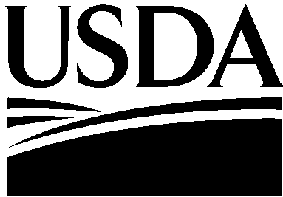

United States Department of Agriculture

Farm and Foreign
Agricultural
Services

Foreign
Agricultural
Service

1400 Independence Ave, SW
Stop 1001
Washington, DC
20250-1001

In response to AQSIQ’s request for registration information on grain export facilities relating to Decree 177 – Administrative Measures for Inspection, Quarantine and Supervision of Inbound and Outbound Grains, I am providing a list of U.S. grain facilities handling U.S. grain exports. This list, which is publicly available, is compiled and administered by USDA’s Grain Inspection, Packers and Stockyards Administration (GIPSA). All U.S. grain exporters who intend to export more than 15,000 metric tons of grain in a given calendar year must register annually with GIPSA. The list captures all major U.S. export grain facilities. The United States believes this will meet your August 5, 2016 request for information.

The United States remains committed to cooperation with AQSIQ as it implements Decree 177. We are confident that U.S. official measures and commercial practices are sufficient to provide for the implementation of Decree 177. We look forward to broadening our understanding of the needs of AQSIQ as it relates to Decree 177. We greatly appreciate AQSIQ’s willingness and interest to learn about the U.S. supply system for products covered by Decree 177 and in providing flexibility to incorporate U.S. measures and practices into your compliance regime. We acknowledge that timely and successful cooperation in implementing Decree 177 may require additional communication between U.S. experts and AQSIQ followed by outreach to the U.S. grain export system.

I propose that a U.S. team of experts on grain trade including the Animal Plant Health Inspection Service (APHIS), GIPSA, FAS and U.S. grain industry representatives meet AQSIQ to provide relevant details on the U.S. official measures and commercial practices as they apply to AQSIQ’s implementation of Decree 177. Dialog between AQSIQ and a U.S. team will provide an understanding of AQSIQ’s needs for implementation of Decree 177 that will be subsequently communicated to the U.S. grain export system.

The export of U.S. grain and oilseeds to China is immensely important to the United States with grain exports to China amounting to nearly $13 billion in 2015. The United States would like to ensure that the requirements of Decree 177 will allow trade to continue according to existing bilateral agreements. In closing, I thank you for China’s ongoing assistance in enacting this measure in a way that allows for dialogue and collaboration in order to minimize disruptions to trade.

Sincerely,

Bruce Zanin
Minister Counselor
U.S. Embassy, Beijing

