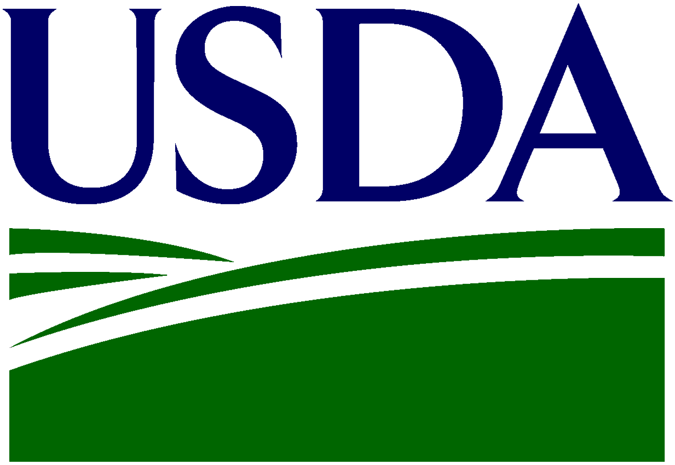
U.S. Department of Agriculture
Foreign Agricultural Service

Agribusiness Trade Mission Application Form

Application Due: September 19, 2016. Please fill out completely.
Save as Word document only.
Return To: trademissions@fas.usda.gov or Alexnadra.baych@fas.usda.gov

Section 1: General Information

Company Name: ____________________________________________________________

Company Logo: (Please enclose separately with application; high resolution files only.)

Company Description: (Please provide a description of your company to be used on printed materials and for sharing with host country businesses.)

Company Overview:
Contact Name & Title
(Person Most Likely to Join ATM):
Address
(Street, City, State, Zip):
Telephone:
E-Mail:
Website:
Market Sector:
Year Established:
Number Of Employees:

Company Designations: (optional; check all that apply)

Female Owned Minority Owned Veteran Owned None of the Above

Section 2: Background Information

Description of Current Products, Services, and Activities:

Description of Current International Activities:

Trade Capacity Volume (Yearly Revenue/Sales):

Section 3: Business Match-Making Profile

Profile of Desired Business Partner: (Please provide information on the sorts of companies with which you are most interested in meeting and be as broad or specific as you prefer.)
Producer:
Processor:
Wholesaler:
Retailer:
Distributor:
Importer/Exporter:
Agency:
Other Institutions:

Desired Size of Potential Partner:
1 – 25 employees
26 – 50 employees
51 – 100 employees
>100 employees

Interpretation Services:
Do you require interpretation services for your business meetings? YES NO

Section 4: Additional Information

What would you like to achieve by joining this Agribusiness Trade Mission?

How did you find out about this Agribusiness Trade Mission?

USDA Announcement

State Department of Agriculture Announcement (State: )

Trade or Industry Organization (Name: )

FAS Website

USDA/FAS Social Media (Facebook, Twitter)

Please Note: The information provided by your company for this application is for internal use by the parties that are involved in the preparation of this mission and will not be disclosed to third parties – except for company name, logo, profile, and contact information. If your company is selected to participate, this information will provide the basis for creating your business matches.

Please return to:
trademissions@fas.usda.gov or alexnadra.baych@fas.usda.gov

U.S. Department of Agriculture | Foreign Agricultural Service | Connecting U.S. Agriculture to the World

